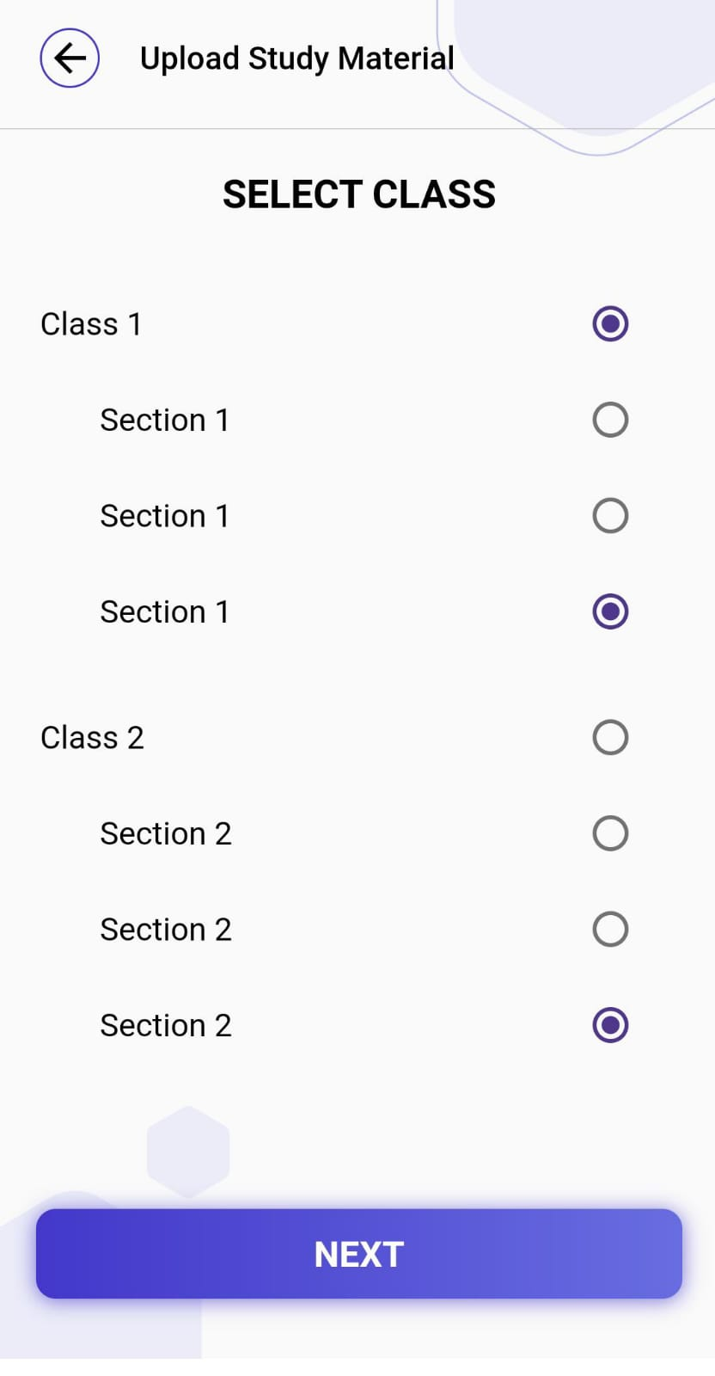

In upload study material when user select section from class 1 after that class 2 same section automatically selected

**Steps to reproduce:**

Login > home upload > class >section

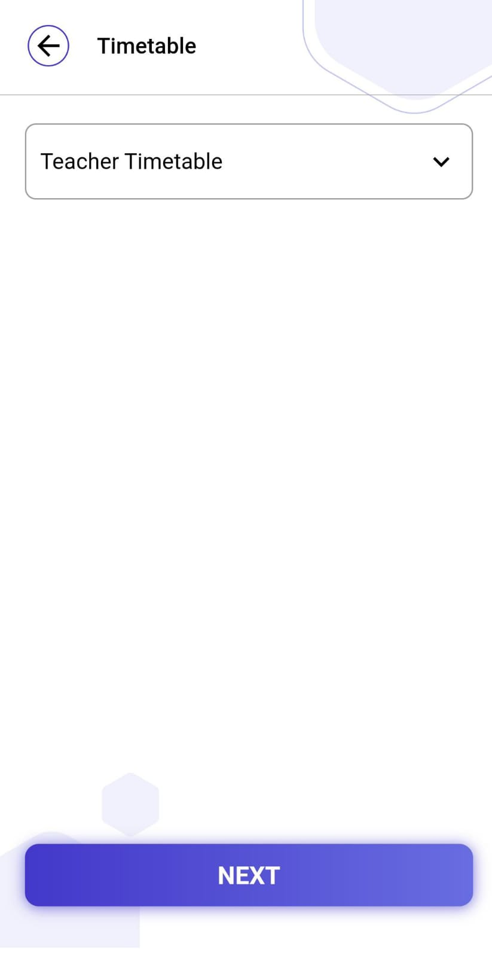

In timetable when user click on teacher timetable teacher dropdown menu not showed.

**Steps to reproduce:**

Login > home > timetable > select session > teacher timetable

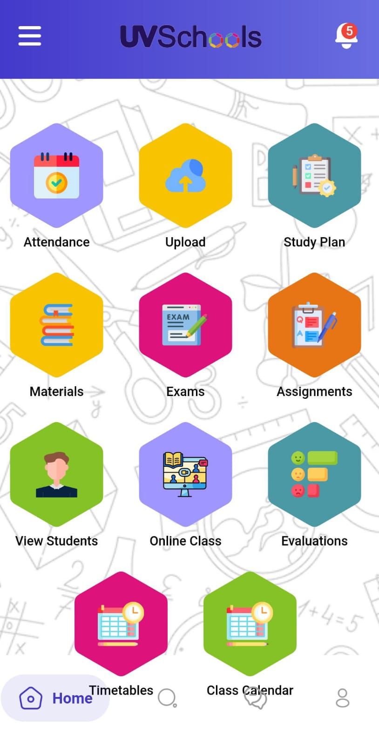

**UI issue :**

Home screen timetable icon and class calender icon overlap with bottom menu bar.

85 % screen work correctly three issue one is teacher timetable and upload study material issue section checkox issue and last one is UI icon overlaping issue.